Composition

* Combination of services
* Similar to composing objects
* Invoking in a certain order

Example:

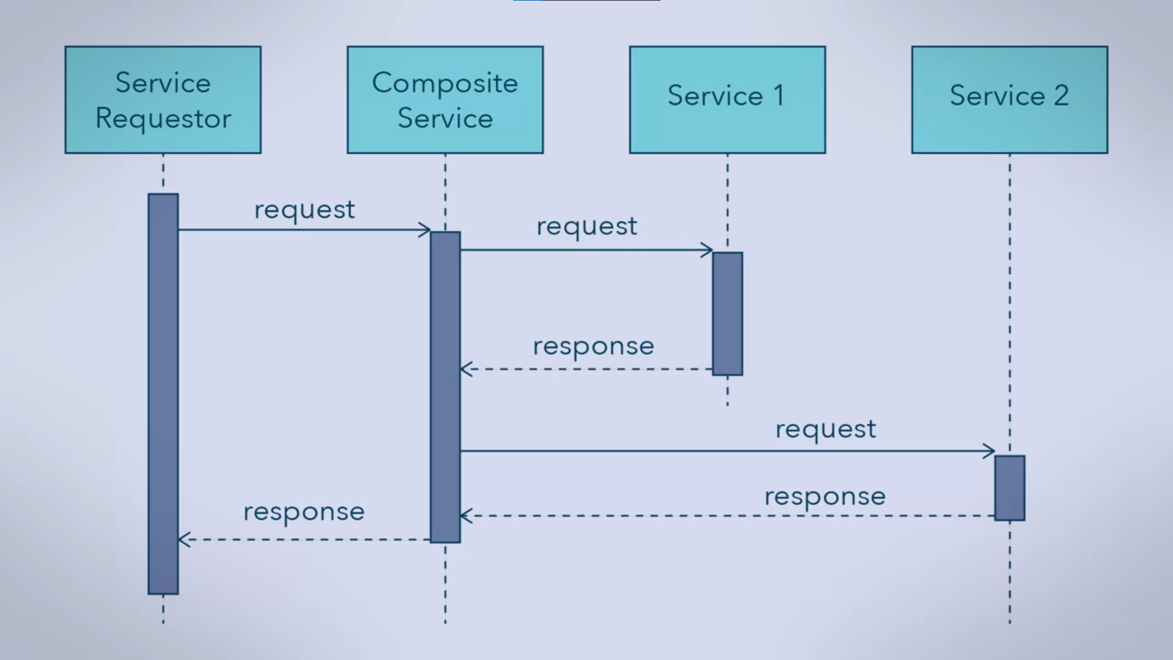

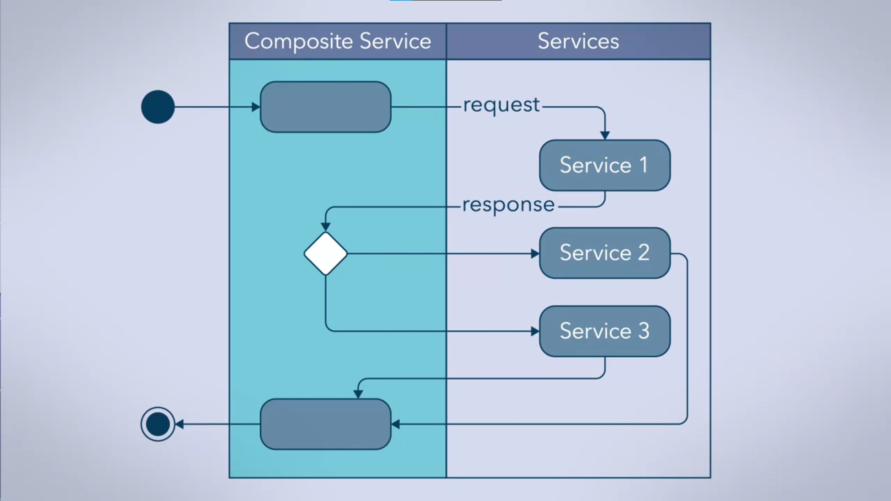

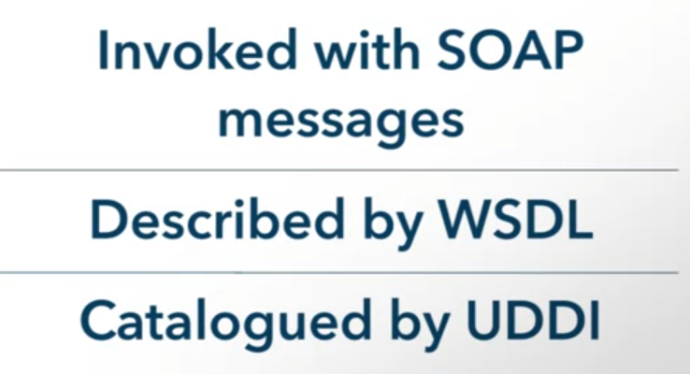

Goal of a Standard for Composing Services:







* WS-BPEL
* Compose compatible services
* Standard for Composition

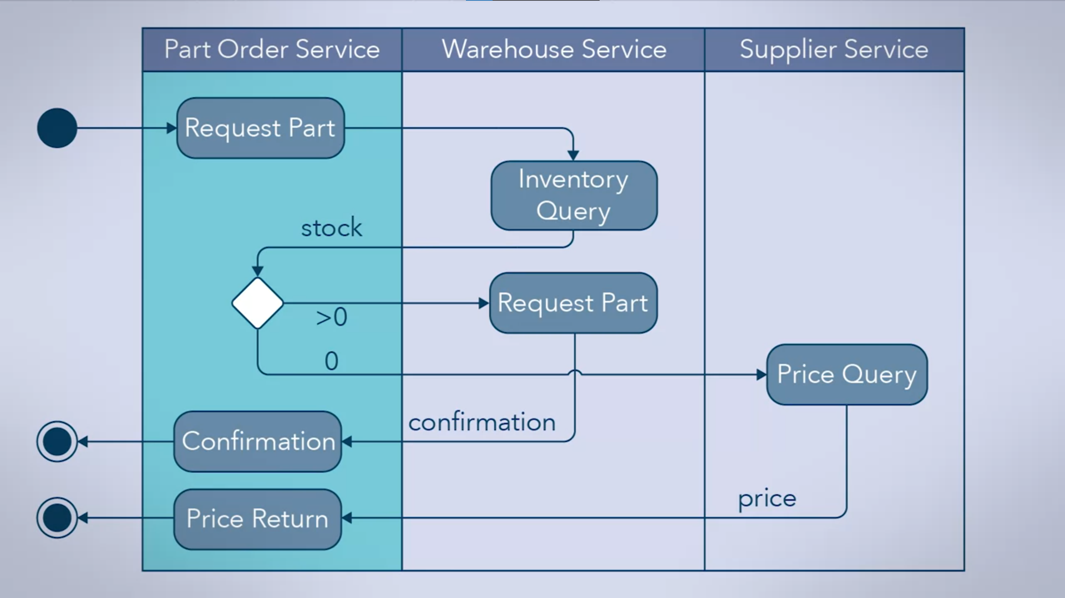

* Combination of internal and external services

Coordination

* Coordinates the activities of 2 or more services

Exposing the actions as another service

* Difference of composition from coordination

Summary

Composing





* Often low-level services
* Combined by WS-BEPL

